Program Design Methods and Intro to Programming Python Final Project Report



**By:**

Michael Christopher

2440047362

Class L1BC

**Lecturer:**

Ida Bagus Kerthyayana

D5757

**Project Specification**

**What’s the project?**

In this project, I made a simple game called, “Survival Tile Breaker”. It is a game which the player is given with a task to smash wall of bricks by deflecting a ball with the platform in the bottom of the screen. This game is highly inspired by a game called “Brick Breaker” released in 1999 for the BlackBerry phone.

**Purpose of the project**

In this project, I create a game in Python for the final project and since it is a game, this project purpose is to provide entertainment for the users. Also, this project allows me to learn more and challenge myself about Python in general and how to implement it in various scenarios and problem solving.

**What’s the vision and mission for this project?**

To make a functional simple program that a lot of people will be able to use to entertain themselves. Since this game has a scoring system, the program needs to know how the scoring system work and how to save the high score system.

**Solution Design**

1. **Introduction**

As a freshmen in BINUS University International with Computer Science as its major, the Python programming language is the first language to be taught to us as the students of Computer Science. We were taught by our lecturer from the most basic stuff like data types, variables, loops and move to the harder one like functions, Python as an OOP, and classes. After approximately 2 months of learning Python, we were given with a final task to make a Python program of their own ideas with some requirements. Students are free to make anything and use any libraries and module in their program and finally, they need to make a presentation and demonstrate their program to the lecturer in command.

This final project task has been announced since the beginning of our university life so we have a lot of times to think what to make and create the program as we learn through lecture after lecture. I didn’t think that much about this project until the end of November and I don’t know what to make until the first week of December. At that time, I am still not certain whether I want to make a game or a website because initially I want to make a game but some people said that at that current time, one of the library for making game in Python, PyGame is not that good because it is slow and a little bit outdated. Until I came found the new Python Arcade library where it is a newer and faster library. After I decided to make a game, now it is time for me to decide what kind of game to make and out of the blue I remember this one particular game called “BrickBreaker” in my old BlackBerry phone and I think maybe it is fun to recreate this game in Python and hence “Survival Tile Breaker” game was born.

I officially started doing this project somewhere in the middle of December 2020 and I use Visual Studio Code as my IDE for this project. This project will be uploaded in my GitHub account, <https://github.com/EuphosiouX/PDM-FinalProject>.

1. **Overview**

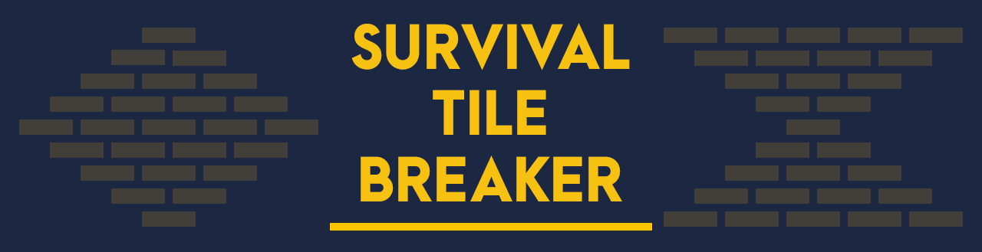

Image 1 - “Survival Tile Breaker” main menu logo

(Logo.png)

“Survival Tile Breaker” is a game here the aim of the game is to destroy the tile by bouncing the ball with a platform in the bottom of the screen. It is designed to be played by people in various age range where the can test their skill and challenge themselves in this game aiming for the highest score. It is also a proper game that provide entertainment.

This game is created in Python 3. 8. 5 3-bit and it uses Arcade 2. 4. 3 external library and modules like random, os, and re.



Image 2 – Python logo

(<https://www.cleanpng.com/png-python-programming-language-computer-programming-c-6370006/>)

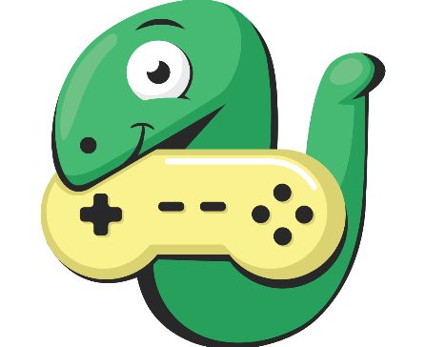

Image 3 – Arcade Library logo

(<https://arcade.academy/_images/arcade-logo.svg>)

1. **Code Flow**

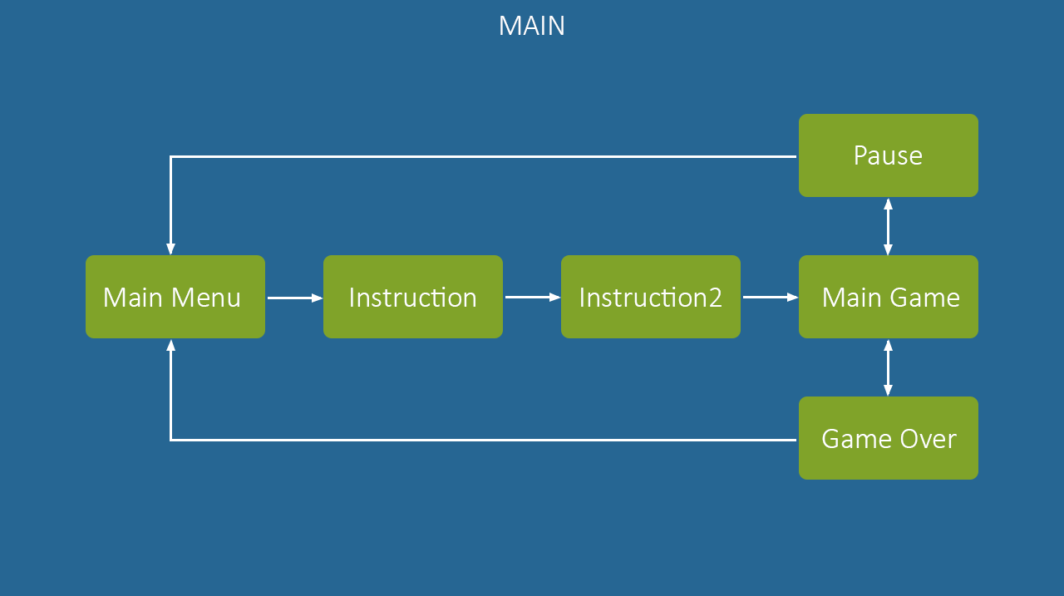

Image 4 – Code flowchart

(CodeFlow.png)

The codes for this program are all inside the main.py file where there a lot of classes inside like MainMenu class, Instruction class, and so on. Each view window has its own class and the way to go to the next view window is by calling the next class.

1. **Visual Design**

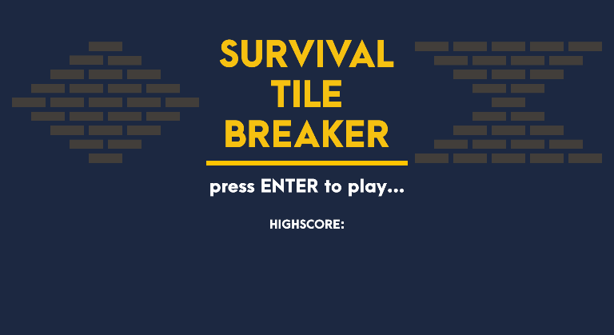The design for this game is simplistic and minimalistic looking for each view window such as, solid background color, simple tile, platform, and ball design, and minimalistic looking main menu title that could also be considered as a logo.

Image 5 – Main menu preview

(MainMenu.png)

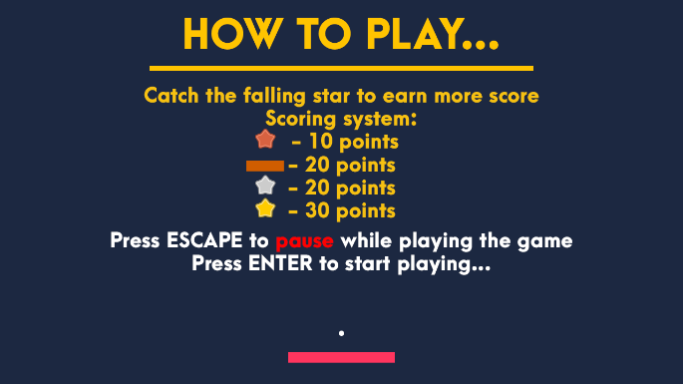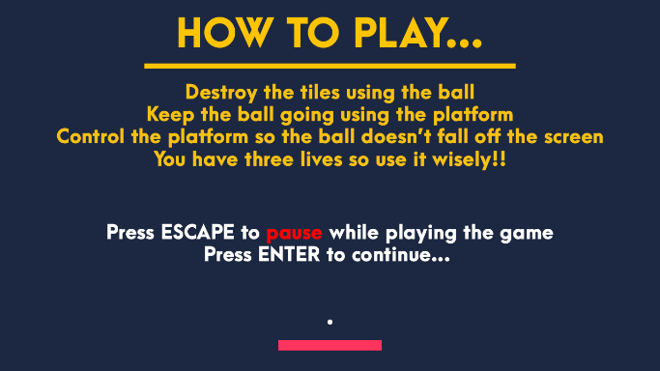

Image 6,7 – Instructions preview

(Instruction.png, Instruction2.png)

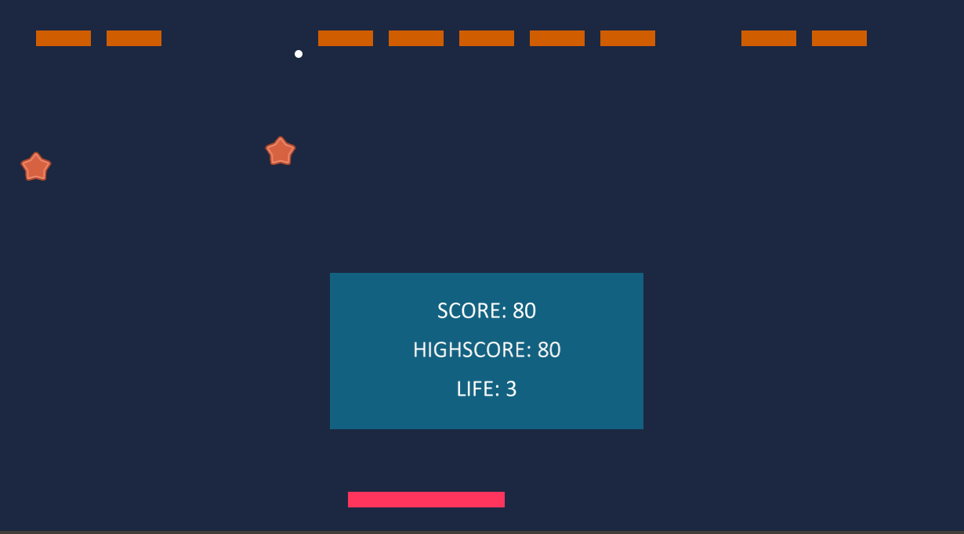

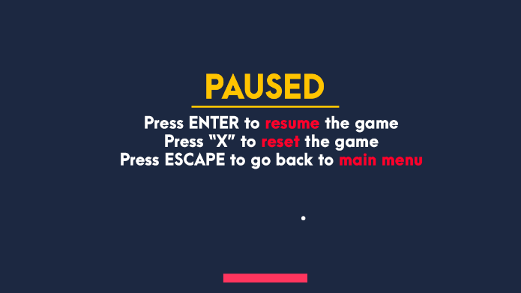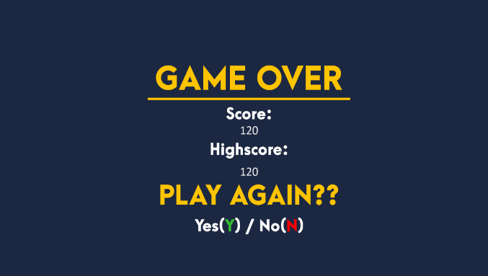Image 8 – Game preview

Image 9,10 – pause and game over preview

(Pause.png, GameOver.png)

**Implementation**

1. **Main Setup**

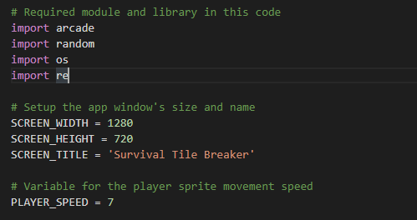

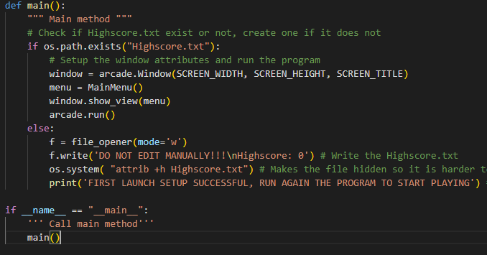

First, I made the main setup variables where I set the window’s size and the name of the game also the player speed variable that will be used later in the game class. I create main() function to set up the window attributes by calling arcade.Window built in class, show the main menu with window.show_view(menu), and finally run the program.

1. **File Opener**

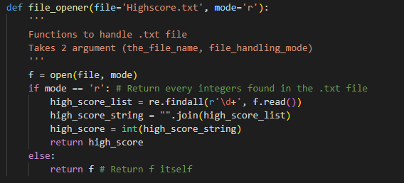

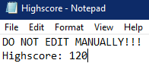 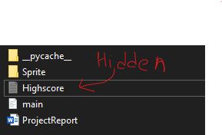

I created this function to handle a file called “highscore.txt” and the player’s high score is saved in this file. Back to the main() function, there is an if and else there and it is to check whether the player have played this game before or it is their first time playing . So this if checks if “Highscore.txt” exist or not in the player’s folder, if not (which every new player doesn’t have), it will run the program, notice that there is no such file, create the file, and print a sentence in the terminal to tell that the setup is successful and run the game again. After that, I realized that by saving the player’s high score data in a .txt file, it is not save since the player can easily access it to change the high score or even delete the file and that’s why I add os.system(“attrib +h highscore.txt) to make it hidden so it is harder to access manually (It is not hidden in the screenshot because I show all hidden files). Run the program again and now it checks if there is such file yes, so it runs the game this time.

1. **Main Menu Class**

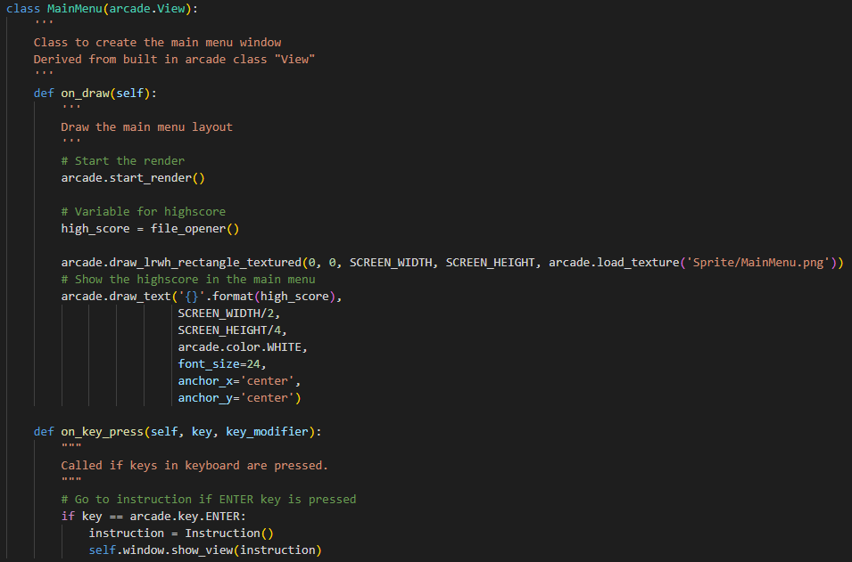

This is the MainMenu class derived from built in arcade class “View”. This class purpose is to show the main menu in the window (Refer to Image 5). Arcade.draw_lrwh_rectangle_textured is to draw the whole main menu window texture and arcade.draw_text is to show the high score in the main menu. Also, I forgot to mention this before but this game only has keyboard control and no mouse control. So, I add on_key_press() to call if the the key is pressed and call the next class if it is pressed.

1. **Instruction Class**

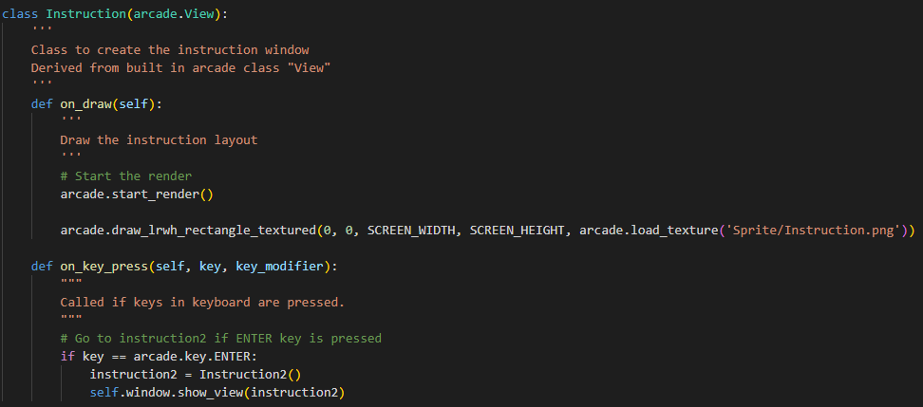

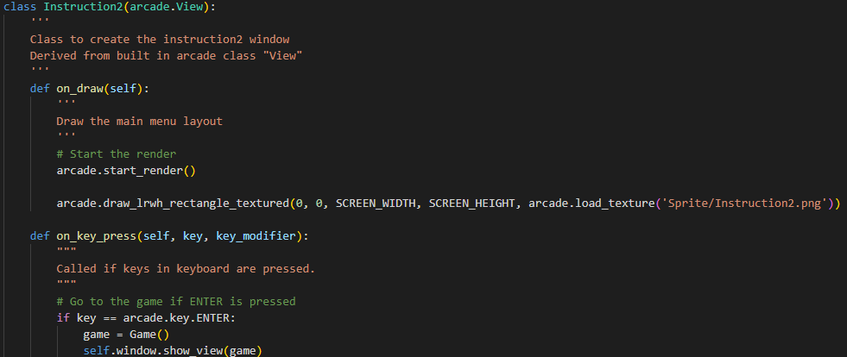

These are the Instruction class also derived from built in arcade class “View”. This class is to show the instruction page of how to play the game and it is consist of 2 pages (Refer to Image 6,7). On_key_pressed() is also added in these classes.

1. **Falling Star Sprite Class**

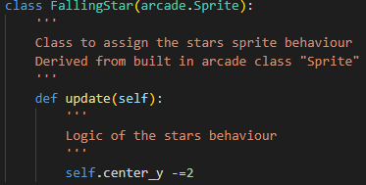

This FallingStar class is to give behaviour to the star sprite later on and the behaviour is on update, move the y-axis position of the star to 2 pixel to the bottom. This class later on together with the Game class will create the star falling from the ceiling animation.

1. **Game Class**

This class has the longest line of code so it will be explained part by part.

1. Instantiation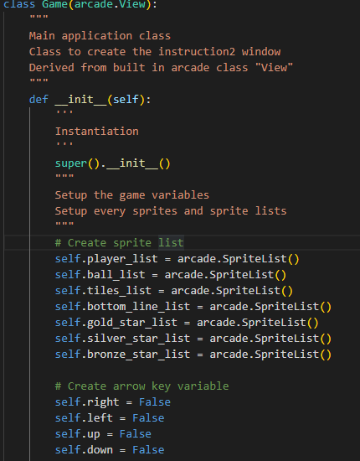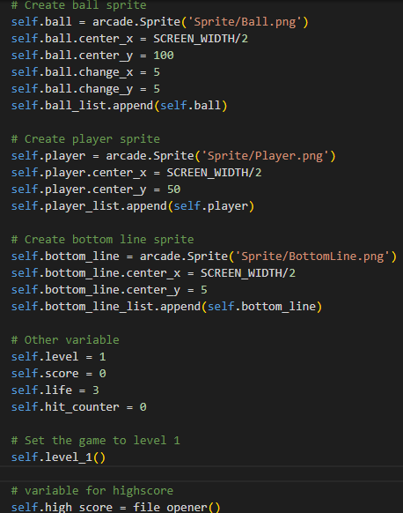

The first thing to do in the game class is to instantiate the all the attributes that are needed such as, setup the sprite object and characteristic, create the sprite list, create the arrow keys variable, create other variables like score, high score, and life, and set the game to level one.

1. 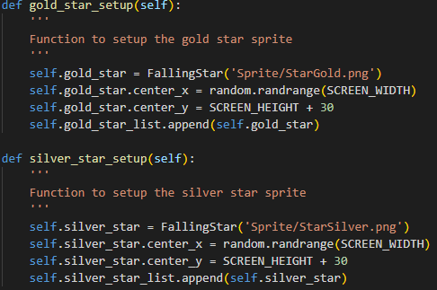Star Function

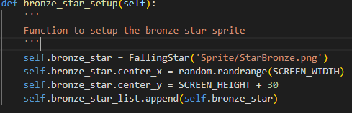

These star function is to setup the star sprite into the game class so the star positioned outside the window in the ceiling an the x-axis position is randomized by using random.randrange so where the star is spawned is randomized.

1. Star Hit Player Function

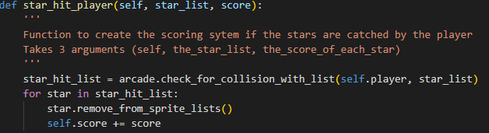

This function is a function to check if the star hit the player below or not if yes, remove the star and add the score according to the amount of score of each star.

1. Star Off Screen Function

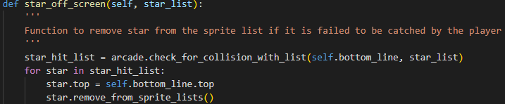

This function is a function to remove all the star that has been spawned but failed to be catched by the player. If this function is deleted, the star that miss the player will keep going down forever and stopped the spawn of the next stars.

1. 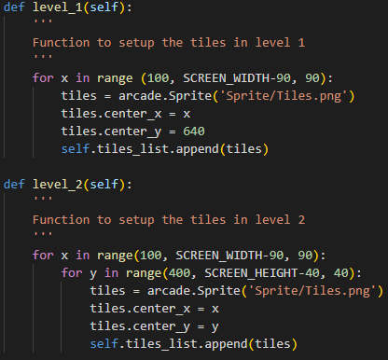Level Function

This function is to setup how each level looks like so it place every single tiles into the game window and so far there are total of 5 levels in this game. Below is how the tiles look like in each level.

Level 1



Level 2

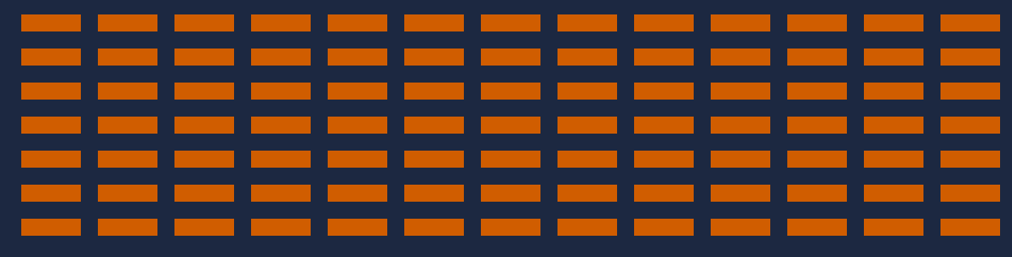

Level 3

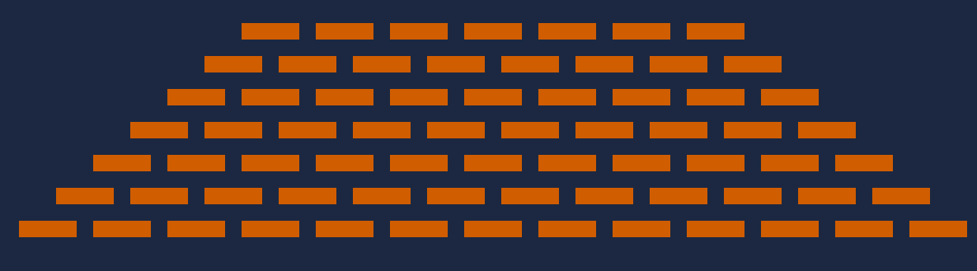

Level 4

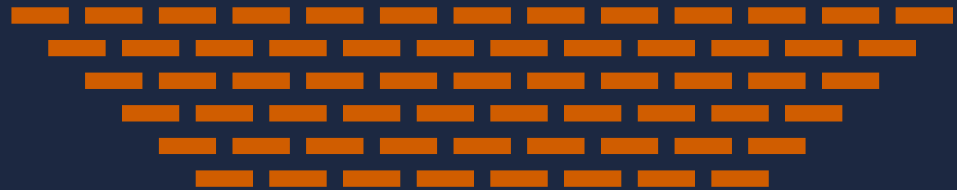

Level 5

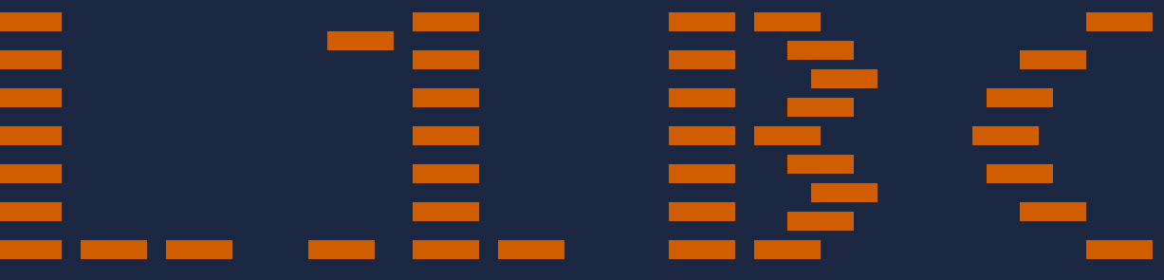

1. On Show Function

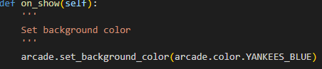

Function to give set the background color.

1. On Draw function

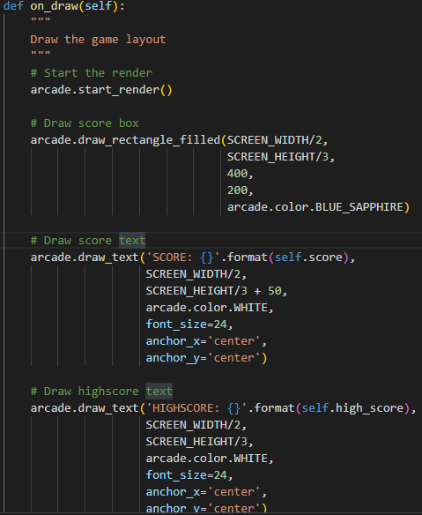

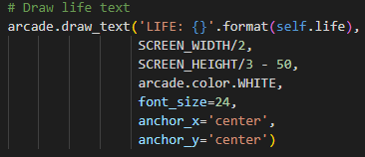

Function to show the score, high score, and life remaining in the game window.

1. On update

This function update the game every 1/60 second so all of the movement logic is inside this function.

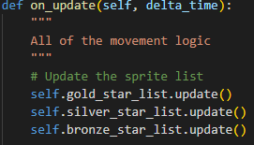Update the star list (it updates the Falling Star Sprite Class which is previously mentioned in number 5).

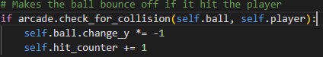Check the ball if it hits the player. Change the y direction of the ball if it hits and add 1 to hit counter

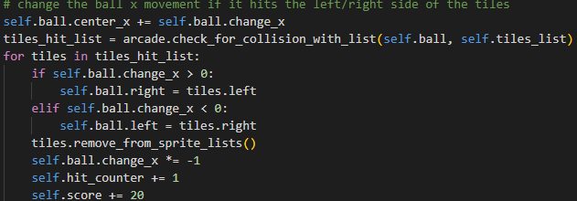Make the ball moves in x position and check if the ball hits the tiles. If the ball hit either the left/right side of the tiles, remove the tiles, add hit counter by 1, and add 20 to score.

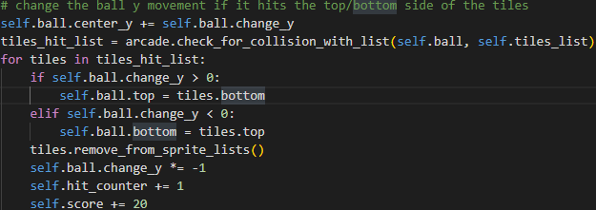Make the ball moves in y position and check if the ball hits the tiles. If the ball hit either the top/bottom side of the tiles, remove the tiles, add hit counter by 1, and add 20 to score.

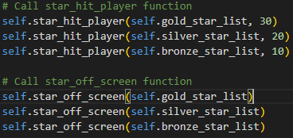Call the Star Hit Player function (Mentioned in number 6c) for each star with their own scoring system. Then, it calls the Star Off Screen System (Mentioned in number 6d) for each star.

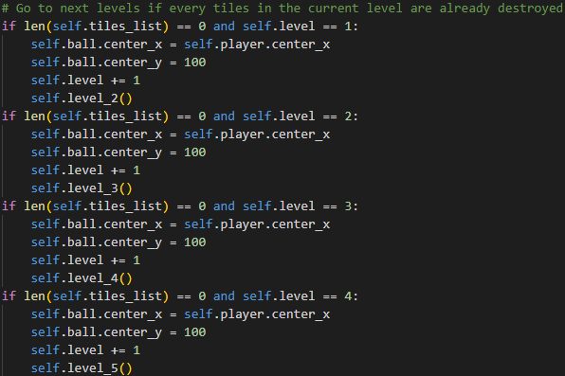

Logic for checking if the tiles in the current level are all completely destroyed if yes, reset the ball position, add 1 to level and move on to the next level.

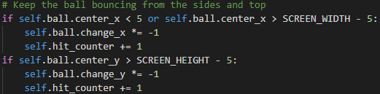

Keep the ball bouncing if it hits the sides and top of the screen.

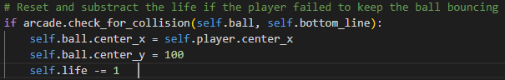 Check if the ball hit the bottom of the screen or no if yes, rest the ball position and substract 1 from life.

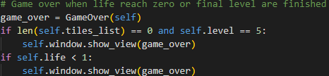Call the Game Over Class (Mentioned in number 7) if the player finished the last level or the player life reach 0.

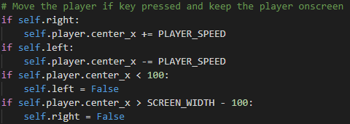Logic for the player movement and to keep the player onscreen

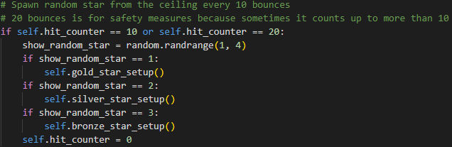

Logic to spawn random stars by calling star function (Mentioned in number 6b) everytime the ball reach 10 bounce.

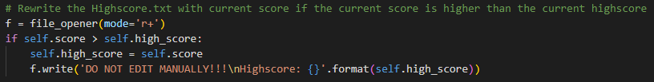

Check if current score is higher that high score or not if yes, change the high score to score.

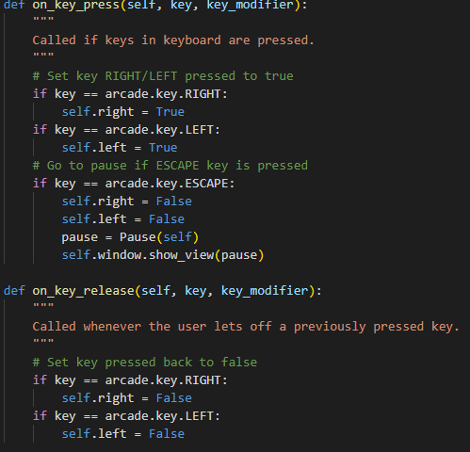

To check if there are any key pressed or no and add the logic for each key pressed. It also define what happen if some of the pressed key are released.

1. **Pause and Game Over Class**

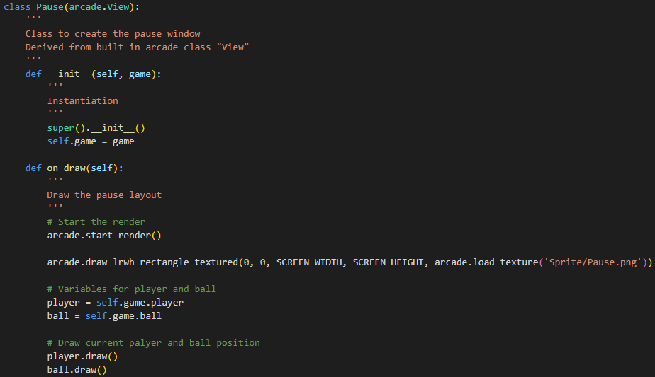

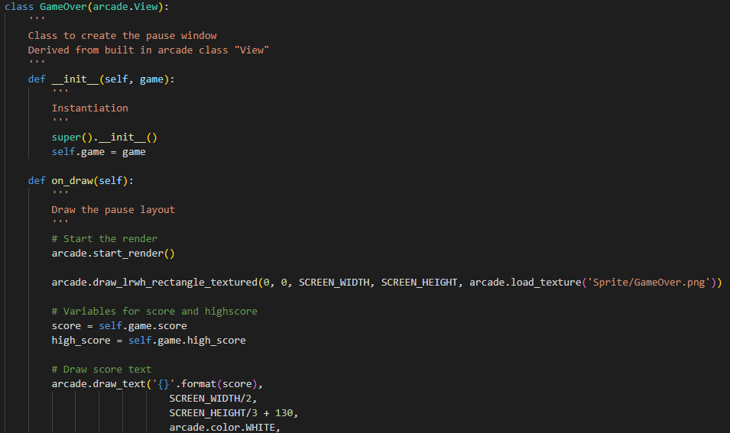

These 2 class are similar to the previous MainMenu class and Instruction class where it shows the window of pause menu and game over menu (Refer to Image – 9,10). The only difference is both of this class have instantiation.

**Evidence Of working Program**

Every screenshot above is taken from my IDE and taken by myself. All of the sprite used are created by me using photoshop (Except the star sprite).

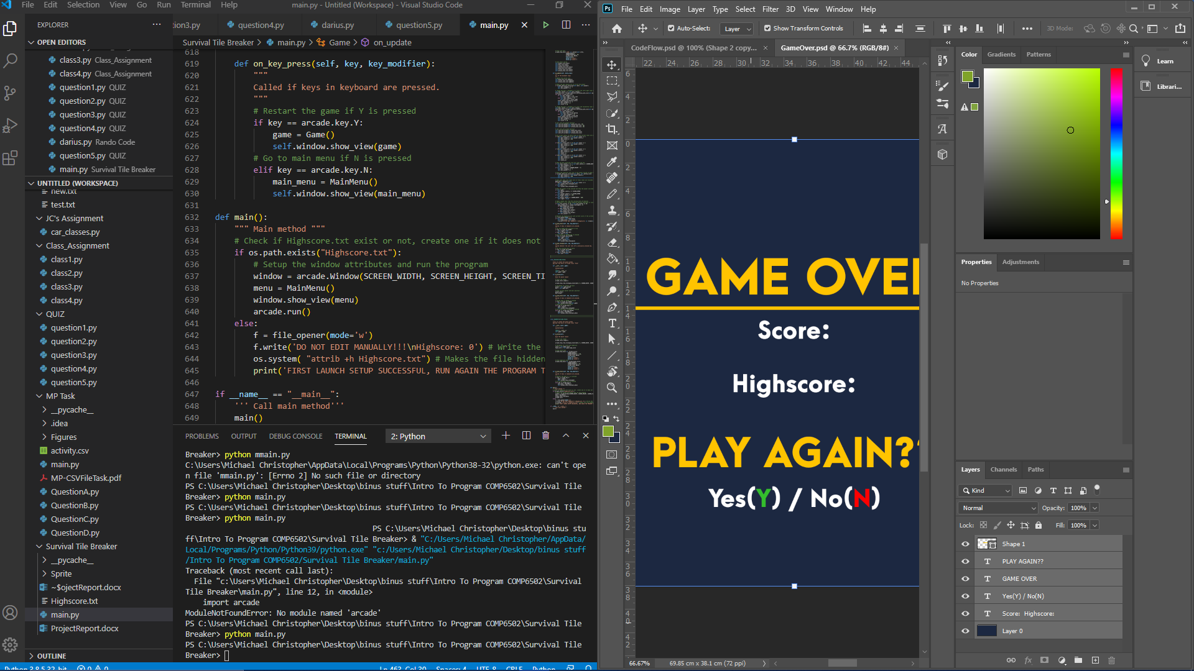

**Summary and Self Reflection**

When I started doing this project, I thought that this is incredibly hard but after learning the libraries from the website, I am finally able to understand how it works and able to implement them in my own program. Overall, this is a really challenging project but in the end, it is pretty fun and this project allows me to know deeper about Python programming language.

**Resource and Reference**

Resource for star sprite:

<https://kenney.nl/assets/tappy-plane>

Reference for some of the code and where I learn Arcade library:

<https://arcade.academy/examples/index.html>

<https://www.youtube.com/watch?v=2qP1M1Nf__w&list=PL1P11yPQAo7pPlDlFEaL3IUbcWnnPcALI>